DT-RLC
Relay actuator

User Manual

DT-RLC

2-WIRE SYSTEM

GND NO COM NC
12V
S2
S1 GND

1
2

POWER
IN-USE
BUS BUS
RISER
3

Please read this manual carefully before using the product you purchase, and
keep it well for future use.We reserve the right to modify the specification in
this manual at any time without notice.
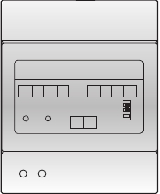



1.About DT-RLC Unit
Description:
The relay actuator DT-RLC is a accessory device designed for DT system to control
door locks or lights. It has the features as follows:
· It has two work modes: lock control mode and light control mode;
· Allows to open gate door locks or control lights;
· Support high power-consumption lock;
· With configurable unlock timed output or light control timed output;
· Support exit control button: when in lock control mode, the exit control button to
control the lock; when in light control mode, the exit control button to control the
light.

2. Parts and Name

NC
COM
NO
GND

DT-RLC

2-WIRE SYSTEM

12V
S2
S1
GND

GND NO COM NC
12V
S2
S1 GND
1
DIP

lock Control
Jumper
1
2
3
POWER
IN-USE
BUS BUS
RISER
2
3
DIP

POWER
IN-USE

BUS

+12V:12V power output. Can be used to power the lock.
S2:Reserved.
S1:Exit button contact. Short this contact and the GND to unlock or control light.
GND:The common Ground of the other 3 contacts: S1, S2 and +12V.

-1-
3
2
1
1 2 3
ON
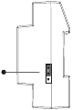

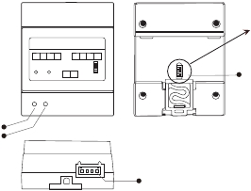

NC:The normally-closed contact to COM.
COM: The common contact of the unlock/light relay.
NO: The normally-open contact to COM.
Lock Control Jumper: To select the lock type: see section 5.3, 5.4.
POWER:Working indicator, it will light up when plugs in power supply.
IN-USE:Unlock/light indicator, it will light up when unlock(or turn on the light).
Bus:Connect to the bus line, no polarity.
DIP :Used for setting the address of the RLC.

3. Unit Mounting

DT-RLC

2-WIRE SYSTEM

DIN Rail Mounting

4. How To Set The Work Mode

Note that the factory default is lock control mode.
1).In DIP1 = ON, DIP2 = ON, DIP3 = OFF status, exit button(S1 and GND) short-
circuit, meanwhile, the DT-RLC will power-on to activate the setting mode;
2).In setting status, struck repeatedly DIP1 four times to switch work modes:
A.When the IN-USE indicator flashes once, it means the system will enter the light
control mode.
B.When the IN-USE indicator flashes two times, it means the system will enter the
lock control mode.
3).When the setting complete,it will automatically restart.
Please note the setting state valid within 5 seconds, more than five seconds without
operation, it will exit the setting mode automatically.

-2-
GND NO COM NC 12V S2 |  |  |  |  | S1 GND
 |  |  |  |  | 123
POWER IN-USE | BUS | BUS | RISER

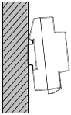

5. Lock Control Mode
In lock control mode, the DT-RLC allows to open gate door locks; Support high power-
consumption lock; With configurable unlock timed output; Support exit control button.

5.1 How to set the unlock time

In lock control mode:
1). Power-on within 5 seconds, short-circuit S2 up to 3 seconds, the IN-USE indicator
flash.
2). Short-circuit S1 up to 3 seconds, and the IN-USE indicator always light.
3). Short-circuit again S2, meanwhile, the time of short-circuit equal to unlock time.
(the IN-USE indicator flashes once per second, Less than two seconds by one second
calculation; The maximum setting time is 30 seconds.)
4). After S2 released, saved unlock time, and exit the setting.

5.2 DIP setting for lock

The DIP switch in the back of the panel is used to set the address of the RLC. Please
refer to the followings for more detail informations about the DIP settings:

-3-
DIP |  |  | Bit State | Descriptions
 |  |  | OFF,OFF,OFF | Applies to door station1 & lock 1
 |  |  | OFF,OFF,ON | Applies to door station1 & lock 2
 |  |  | ON,OFF,OFF | Applies to door station2 & lock 1
 |  |  | ON,OFF,ON | Applies to door station2 & lock 2
 |  |  | OFF,ON,OFF | Applies to door station3 & lock 1

2
1
2
1
3
ON
2
1
3
ON
2
1
3
ON
2
1
3
ON
3
ON

5.3 Internal powered lock connection(only suitable for Power-on-to-
unlock type)

DT-RLC control the second lock of door station 1

E-lock

AC~

+
-

Exit Button

1# Camera
(Device Address:0)

GND NO COM NC

12V S2 S1 GND

monitor

PC6

DT-RLC
GND NO COM NC
POWER IN-USE

2-WIRE SYSTEM
12V S2 S1 GND
1
2
3
BUS BUS RISER

BUS(IM) BUS(DS)

L1
L2 PL S+ S-

-
+

-4-
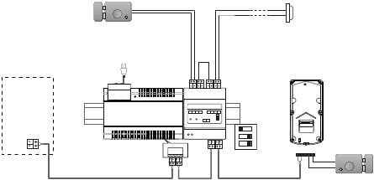

DIP |  |  | Bit State | Descriptions
 |  |  | OFF,ON,ON | Applies to door station3 & lock 2
 |  |  | ON,ON,OFF | Applies to door station4 & lock 1
 |  |  | ON,ON,ON | Applies to door station4 & lock 2

3
2
1
DIP
ON
2
1
2
1
3
ON
1
3
ON
2
3
ON

DT-RLC connect lock

Note:

+

1.
When DT-RLC connect Electronic
E-lock
-
* Exit Button

lock, the jumper position in 1-2.

2.
When DT-RLC connect E-magnetic
lock, the jumper position in 2-3.

GND NO COM NC

12V S2 S1 GND

1 2 3

DT-RLC

5.4 External Power Supply powered lock connection

A. Power-on-to-unlock type:
DT-RLC control the second lock of door station 1

adaptor for the lock
Jumper position in 1-2

E-lock

-
+

Exit Button

monitor

AC~

BUS(IM) BUS(DS)

GND NO COM NC

12V S2 S1 GND

1# Camera
(Device Address:0)

L1
L2 PL S+ S-

-
+

-5-
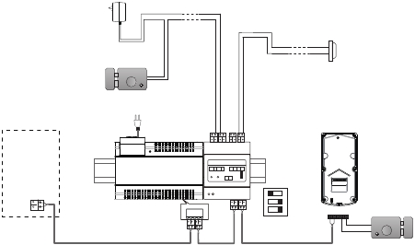

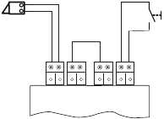

 | DT-RLC 2-WIRE SYSTEM
PC6 | GND NO COM NC 12V S2 S1 GND123BUS BUS RISERPOWER IN-USE

3
2
1
DIP
ON

DT-RLC connect lock

Note:
1. Here's lock type is

E-lock

POWER
SUPPLY

* Exit Button

Electronic lock.

GND NO COM NC

12V S2 S1 GND

1 2 3

DT-RLC

B.Power-off-to-unlock type:
DT-RLC control the second lock of door station 1

adaptor for the lock
Jumper position in 1-2

EM-lock

-
+

Exit Button

AC~

GND NO COM NC

12V S2 S1 GND

1# Camera
(Device Address:0)

monitor

PC6

DT-RLC
GND NO COM NC
POWER IN-USE

2-WIRE SYSTEM
12V S2 S1 GND
1
2
3
BUS BUS RISER

BUS(IM) BUS(DS)

L1
L2 PL S+ S-

-
+

-6-
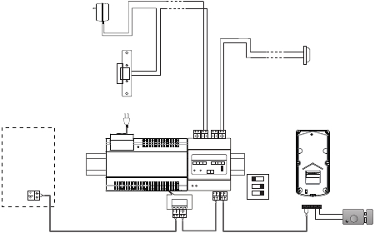

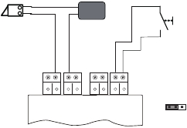

+
3
2
1
DIP
ON
-

DT-RLC connect lock

Note:
1. Here's lock type is

POWER
SUPPLY

EM-LOCK

* Exit Button

E-magnetic lock.

GND NO COM NC

12V S2 S1 GND

1 2 3

DT-RLC
Jumper position in 2-3

6. Light Control Mode
In light control mode, the DT-RLC allows to control lights; With configurable light timed
output; Support exit control button.

6.1 How to set the light working time
In light control mode:
1). Power-on within 5 seconds, short-circuit S2 up to 3 seconds, the IN-USE indicator
flash.
2). Short-circuit S1 up to 3 seconds, and the IN-USE indicator always light.
3). Short-circuit again S2, meanwhile, the time of short-circuit 1 seconds equal to
light working time 30 seconds.(the IN-USE indicator flashes once per second; The
maximum setting time is 900 seconds.)
4). After S2 released, saved unlock time, and exit the setting.

6.2 DIP setting for light

-7-
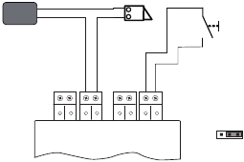

DIP |  |  | Bit State | Descriptions
 |  |  | OFF,OFF,OFF | Set to the first DT-RLC.

-
+
2
1
3
ON

6.3 DT-RLC Connections for Light Control

110~250V AC Input

AC~
(Device Address:0)

monitor

BUS(IM) BUS(DS)

GND NO COM NC

12V S2 S1 GND

L1
L2 PL S+ S-

-
+

-8-
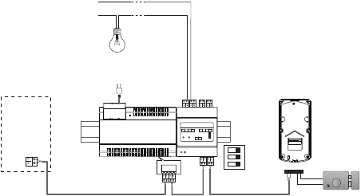

DIP |  |  | Bit State | Descriptions
 |  |  | OFF,OFF,ON | Set to the second DT-RLC.
 |  |  | ON,OFF,OFF | Set to the third DT-RLC.
 |  |  | ON,OFF,ON | Set to the fourth DT-RLC.
 |  |  | OFF,ON,OFF | Set to the fifth DT-RLC.
 |  |  | OFF,ON,ON | Set to the sixth DT-RLC.
 |  |  | ON,ON,OFF | Set to the seventh DT-RLC.
 |  |  | ON,ON,ON | Set to the eighth DT-RLC.

 | DT-RLC 2-WIRE SYSTEM
PC6 | GND NO COM NC 12V S2 S1 GND123BUS BUS RISERPOWER IN-USE

3
2
1
DIP
ON
2
1
2
1
3
ON
2
1
3
ON
2
1
3
ON
2
1
3
ON
2
1
3
ON
1
3
ON
2
3
ON

7. Connecting 2 DT-RLCs

In one system, you can connect a DT-RLC to control gate door lock, and connect
another DT-RLC to control light.

adaptor for the lock

E-lock

Safety Type: power-on to open
power-off to lock

GND NO COM NC

12V S2 S1 GND
Exit Button

DT-RLC

POWER IN-USE

110~250V AC Input

AC~

N

N

L

SW

LED

GND NO COM NC
12V S2 S1 GND

PC6

DT-RLC

POWER IN-USE
BUS(IM) BUS(DS)

monitor

RF CARD

(Device Address:0)

-9-
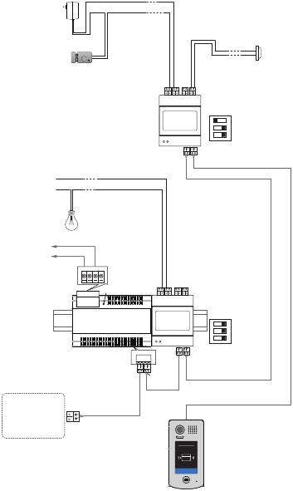

3
ON
2
1
3
2
1
DIP
ON
DIP

8. Specification

·
·
·
·
·

Power Supply :
Unlocking Time:
Lock Power supply:
Working Temperature:
Dimension:

DC24V;
1~30s(Default 1s);
12Vdc, 450mA(Internal Power);
-100C~+400C;
89(H)×71(W)×45(D)mm.

The design and specifications can be changed without notice to the user. Right to interpret
and copyright of this manual are preserved.

DT-ENG-RLC-V2

20150916

